I chose to model the shortest cost distance from Boston to San Diego, Charleston to Bend, and New Orleans to Bozeman. The shortest path from Boston, MA to San Diego, CA is about 3,024 miles. This path has a path cost of 2,940,196. To drive from Boston to San Diego, it would take about 2,940 minutes or 49 hours. The shortest path from Charleston, SC to Bend, OR is about 2,769 miles. This path has a path cost of 2,760,426. Taking this path to Bend from Charleston would take about 2,760 minutes or 46 hours. The shortest route from New Orleans, LA to Bozeman, MT is about 1,983 miles with a path cost of 1,994,954. Driving from New Orleans to Bozeman would take about 1,995 minutes or 33 hours.
Map:
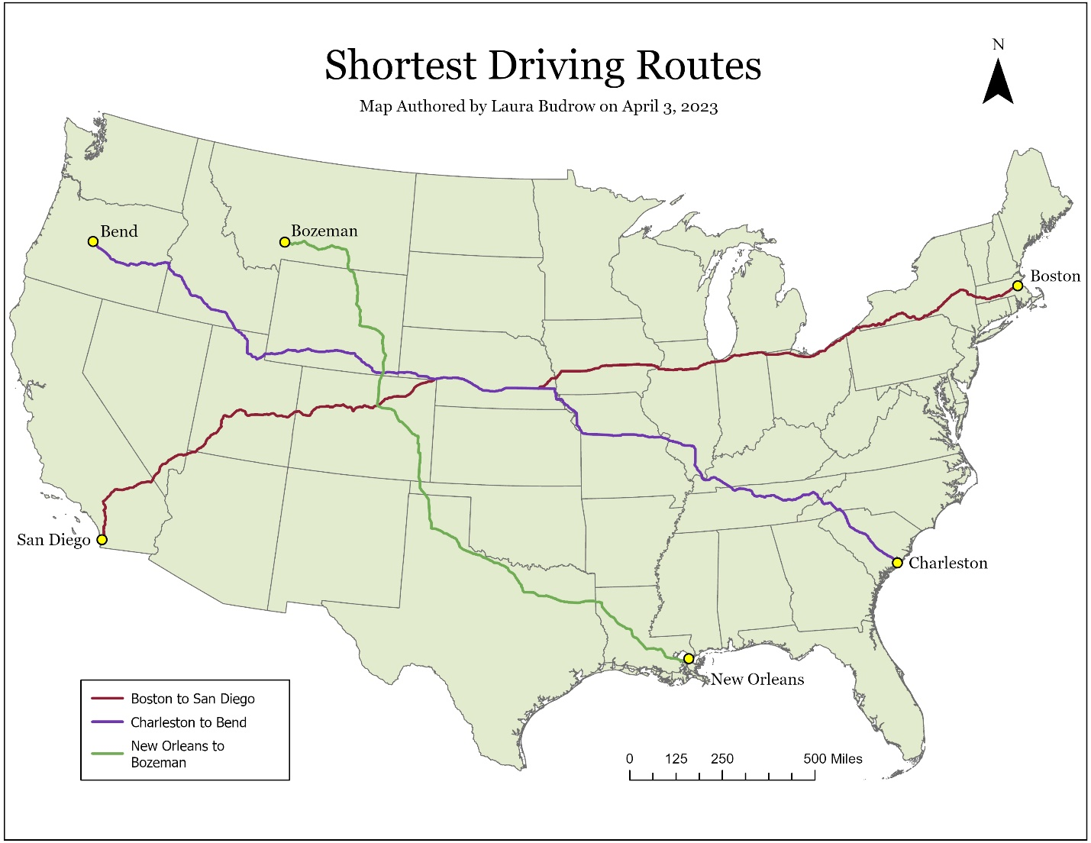
Model:
